**Name: Sriram.M**

**Reg no:1919103121**

**Assignment-II**

Build a python code, Assume u get temperature and humidity values (generated with random function to a variable) and write a condition to continuously detect alarm in case of high temperature.

**Code:**

import random

while(True):

a=random.randint(10,99)

b=random.randint(10,99)

if(a>50 and b>80):

print("high temprature and humidity of:",a,b,"%","alarm is on")

elif(a<45 and b<65):

print("Normal temprature and humidity of:",a,b,"%","alarm is off")

break

**Input:**

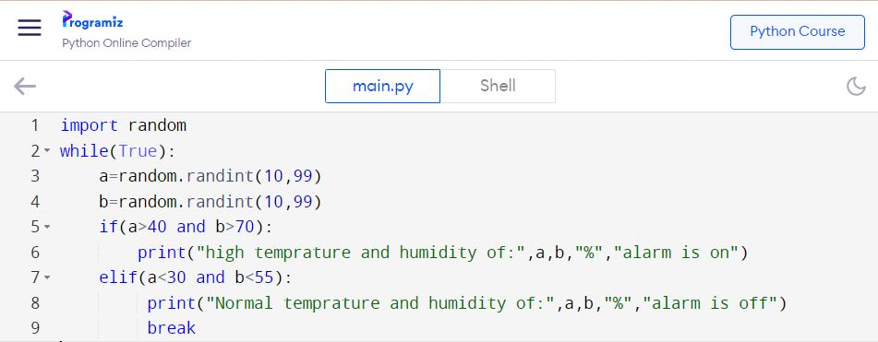

**Output:**

